Business Web technologies Assignment:

Name: Priyasnee Boolaky

Tutor: Mr Veerajy

ID: 20380009

Table of Content

**System Architecture Report** **2**

**Plug-Ins Justification** **5**

**Performance:** **9**

**Non-conformance report** **12**

**References:** **17**

# System Architecture Report

Introduction:

A system architecture illustrates the system processes and flow of work of the software that dictates how the application/webpage works(Spacey 2018). In our case, we are going to define the processes of our membership website and the logical flow of work behind it. Henceforth, this report will showcase the overview of our website system and use visual representation to display how the logical work process flow interacts with each other to create our system. This will have for effect to portray the architectural decisions that were taken while working on this website.

Scope:

This report shows the work on the Taylor blog membership website and it will display the architectural view of the system and its inner workings.

An overview of the thought process behind the blog membership website is that as the creator of this website, I tried to implement a membership system that will allow users to gain access to premium or free features that the website offers.

Architectural Goals:

* Implement a membership system
* Members can access data provided only based on their membership type
* Non-members can still register and access the full site.
* Users who are not registered or members are offered the bare minimum and basic version of the webpage.

System workflow view:

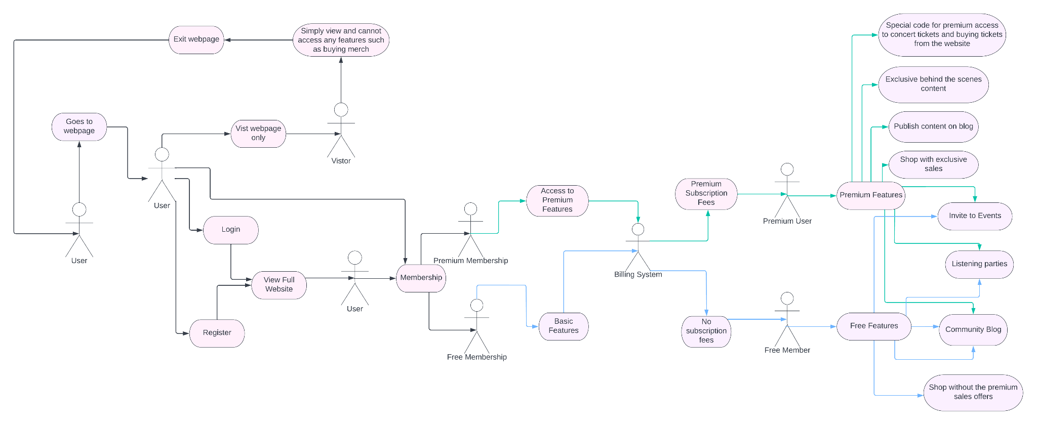

Description of system workflow:

As we can see in the above diagram, a user can simply go to the webpage where they can either log in, register or just view the page. During this process, the system can classify users into three categories: Visitor, Users with an account or users who want to register and create an account.

Next up are the account options in the system, a user can create an account using two different functions: Register or Membership function. The register function allows users to create an account to view the full website and see the benefits of becoming a member. If a user wishes to access the projects section of the web page, they will have to attach a membership status to their account.

The Membership function allows users to create an account and already attach a membership level to their account. This way, the users can already access the various features attached to the two levels.

Now, while signing up for a membership level, you can choose two levels: Free or premium:

Premium gives unlimited access to all the features and the Free level gives restricted access.

Processes View:

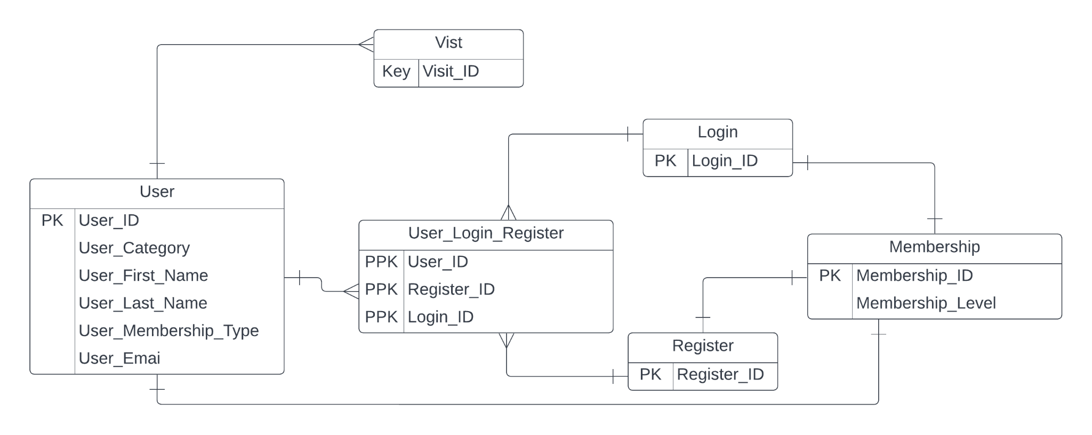

# Plug-Ins Justification

For this website, I used multiple plug-ins to make it function the way I wanted it to act. Below is the list are plug-ins used for this website:

Table 1:

| Plug-In | Description |
| --- | --- |
| Astra Widgets | Astra-Widgets is a plug-in that allows you to utilise widgets to add an address, lists of icons or social media to any element of your website.  It allowed me to customise my website by adding widgets in the footer such as the copyrights claim seen at the end of each web page. This plug-in came pre-installed with the template I chose to use to create my website. Moreover, it was a welcome feature as it came in handy and gave me the means to design the website like I wanted to. |
| Elementor | Elementor is a website builder plug-in. |
| Elementor Header and footer builder | This plug-in help create and design the header and footer of the webpages. |
| Paid Memberships Pro | Paid Memberships Pro plug-in allows you to have the tools to create a membership website whereby you can restrict content access to different membership levels, etc. |
| Site Kit by Google | This is one of the performance plug-ins, I decided to use. Site Kit is presented as an analytical tool that uses Google tools to ensure that you get the best insights on how your website is performing.  I decided to use this plug-in as it is an easy to use plug-in which gives me my website’s performance detail as well as suggestions on how to improve my website.  It lets me know more about my website such as how many users navigated my site and allowed me to understand more about the SEO of my webpage. I also used it to optimize my website. |
| Query Monitor | This plug-in is known as a developer tool panel. It allows the developer to solve database queries, PHP errors, hooks and actions, block editor blocks, etc.  It was the perfect tool for me to know, evaluate and analyse all the potential errors that are slowing down my website. |
| Rank Math SEO | SEO is a highly important feature of a website for its success and Rank Math SEO was the perfect plug-in to improve my website and increase traffic to the page. |
| Really Simple SSL | This is a plug-in that automatically analyses your settings and modifies your website to run over HTTPS.  It is also a lightweight plug-in as the developers kept the options of this plug-in to a minimum. I used this plug-in to allow my website to run over HTTPS as it guarantees a secure connection which is the bare requirement when you are developing a membership website.  Having my website run over HTTPS is needed to ensure that the payment transactions that come with subscribing to a membership level are secure.  Overall, having this layer of security is crucial for protecting the integrity of my website’s data. |
| Sassy Social Share | This is a social media plug-in. It allows the website users to share the content they find interesting to various social media platforms notably Instagram, Twitter, Facebook, etc.  This plug-in was chosen because I wanted my website users to be able to promote my website's content as a means to increase users/members. |
| Total Upkeep | This plug-in came as a recommendation from another plug-in: WP-Optimize.  This happen while I was optimizing my website’s images and purging its cache.  Anyway, Total Upkeep is a necessary plug-in for any website since it is a backup plugin but I specifically chose this one because it is not only a backup measure but also a preventive one. Total Upkeep also prevents the website from crashing. |
| Ultimate Member, | This is another membership plug-in that has specific features for logged in and out users.  The main feature that I used from this plug-in: Conditional nav menus.  I used it to implement the content restriction as well as it allows specific users to get access to specific menu displays according to their status as users.  For example, a logged-in user is presented with a log-out button and vice versa. |
| WP-Optimize | It is an essential plug-in performance-wise. Since Wp-Optimize is a solution to your website’s troubles as it caches your site, cleans your database and compresses your images. |

Data from (“WordPress Plugins” 2022).

Elementor Website Builder plug-in

As previously mentioned, Elementor is a plug-in that helped me build my website. From providing the template to using the feature Edit with Elementor to personalize my webpages to my liking.

Nevertheless, there is a variety of website builders available on WordPress, hence why did I choose Elementor.

Elementor is known to be one of the best website builders on the market, it gives you a ton of variety while choosing a template and also give a lot of creative control over how you want your website to be and behave. Their theme builder is what made them such a popular feature.

Table 2:

| Elementor | Ratings | Beaver Builder | Ratings |
| --- | --- | --- | --- |
| Interface | 5/5 | Interface | 4.5/5 |
| Included Widgets/Templates | 5/5 | Included Widgets/Templates | 4/5 |
| Styling Options | 5/5 | Styling Options | 5/5 |
| Performance | 4/5 | Performance | 5/5 |

Data from (Newcomer 2016)

Table 2 above shows a comparison between Elementor and Beaver Builder, two website builder and how they go head to head.

Nevertheless, in all honesty, Elementor has way more features as such, it is a much more heavy page builder in comparison to Beaver Builder, hence explaining the performance difference between the two.

As shown in the table, it clearly shows that Elementor has the better overall aspects hence one of the reasons why I choose to use this plug-in and builder for my website.

Moreover, Elementor is also compatible with another plug-in I used: Rank Math SEO. When it came to choosing a plug-in for SEO performance, the compatibility with Elementor played an important role in installing Rank Math SEO over its other competitors.

WP-Optimize

This is a plug-in that drastically helped improve my performance. After doing the first performance speed test on my website, the results were horrible and after analysing the results and recommendations to improve my website’s speed. I had to install a plug-in that help me with optimizing my website and increase its speed.

Hence, I was stuck between choosing two of the best plug-ins: WP-Optimize and W3 Total Cache.

Table 3:

|  | Ratings | Active Installations |
| --- | --- | --- |
| WP-Optimize | 5/5 stars | 1 million + |
| W3 Total Cache | 4.5/5 stars | 1 million + |

Data from (“WordPress Plugins” 2022)

As described above, both are closely matched but the reason which edges WP-Optimize is that the free subscription offering is better than W3 Total Cache’s free version. WP-Optimize also has the better cleaning database function among the two of them(“WP-Optimize vs W3 Total Cache Comparison [05-2022]” 2022).

# Performance:

GTmetrix:

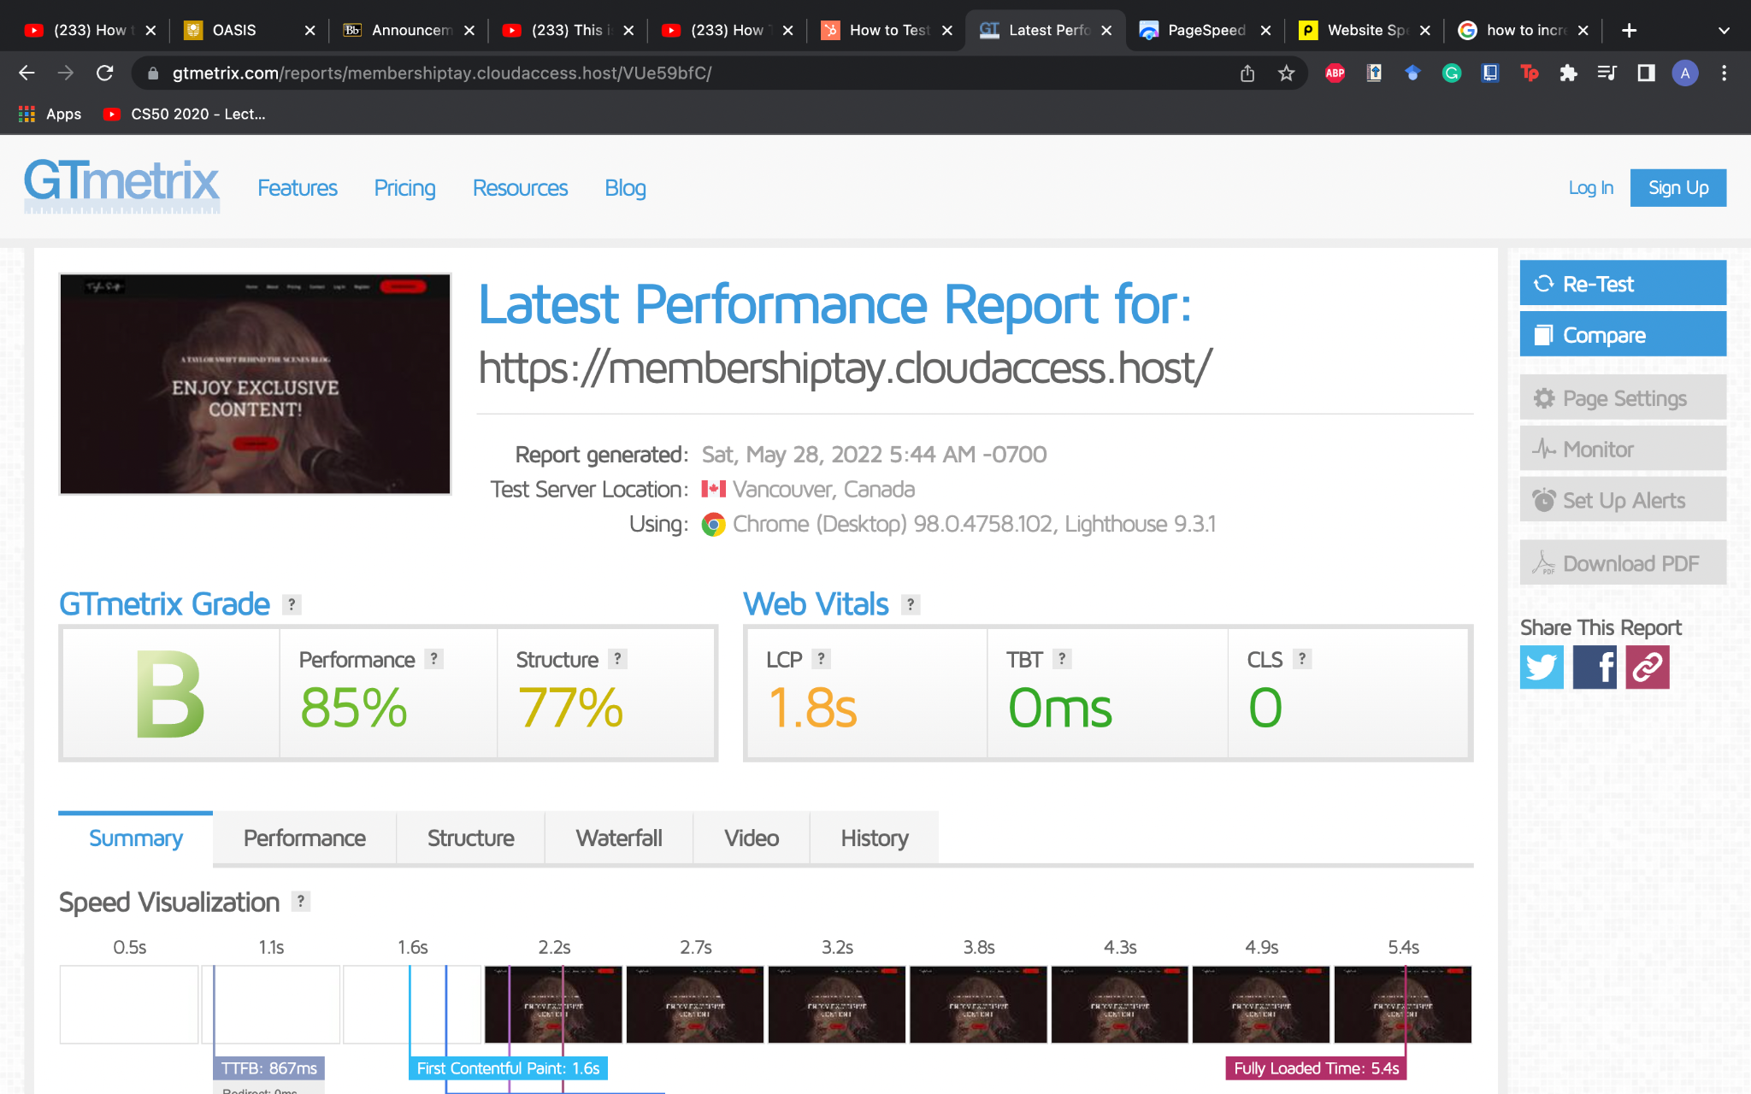

Pingdoom testing:

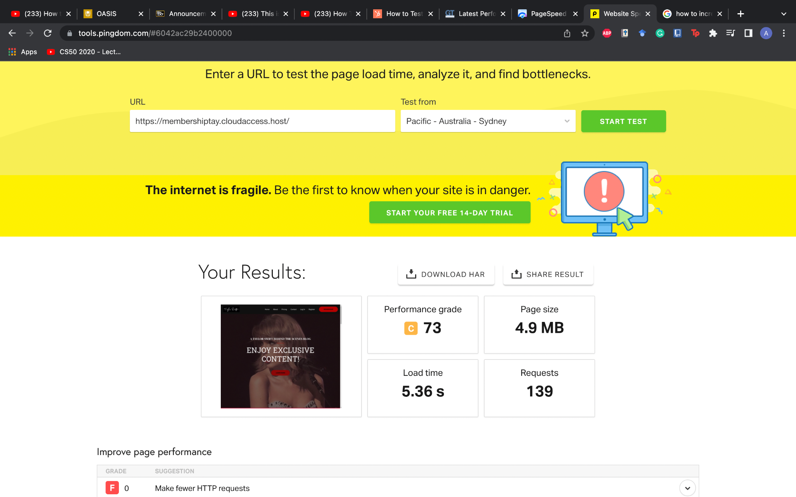

The above pictures were tests that occurred before I installed WP Optimize and compressed the image database that my website was using:

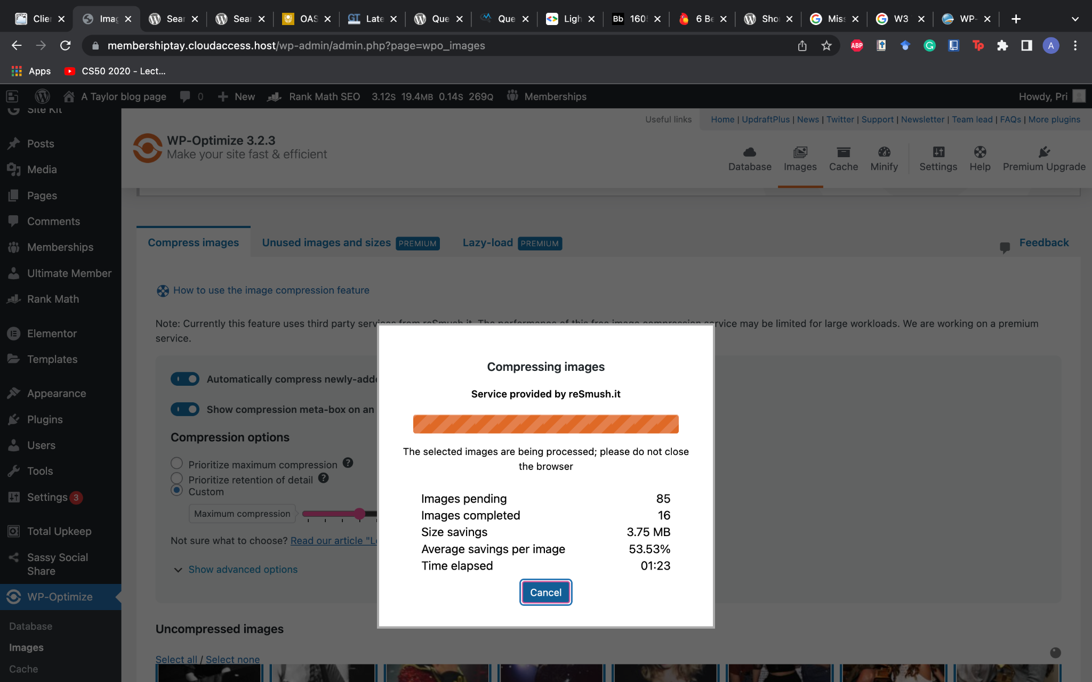

The plug-in at work compressing the images file.

After optimizing a few other optimization processes and compressing the image file, I ran a few more tests which gave an improved result from the above testing results:

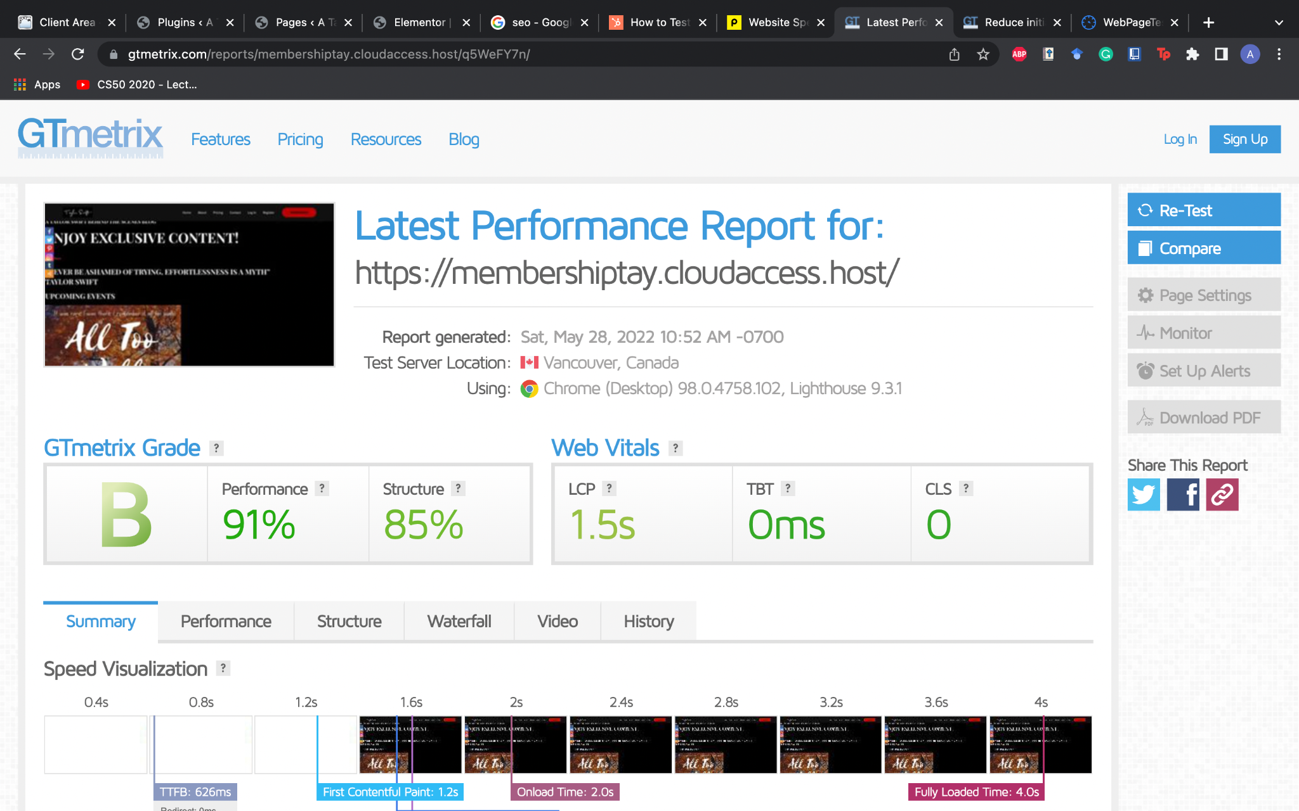

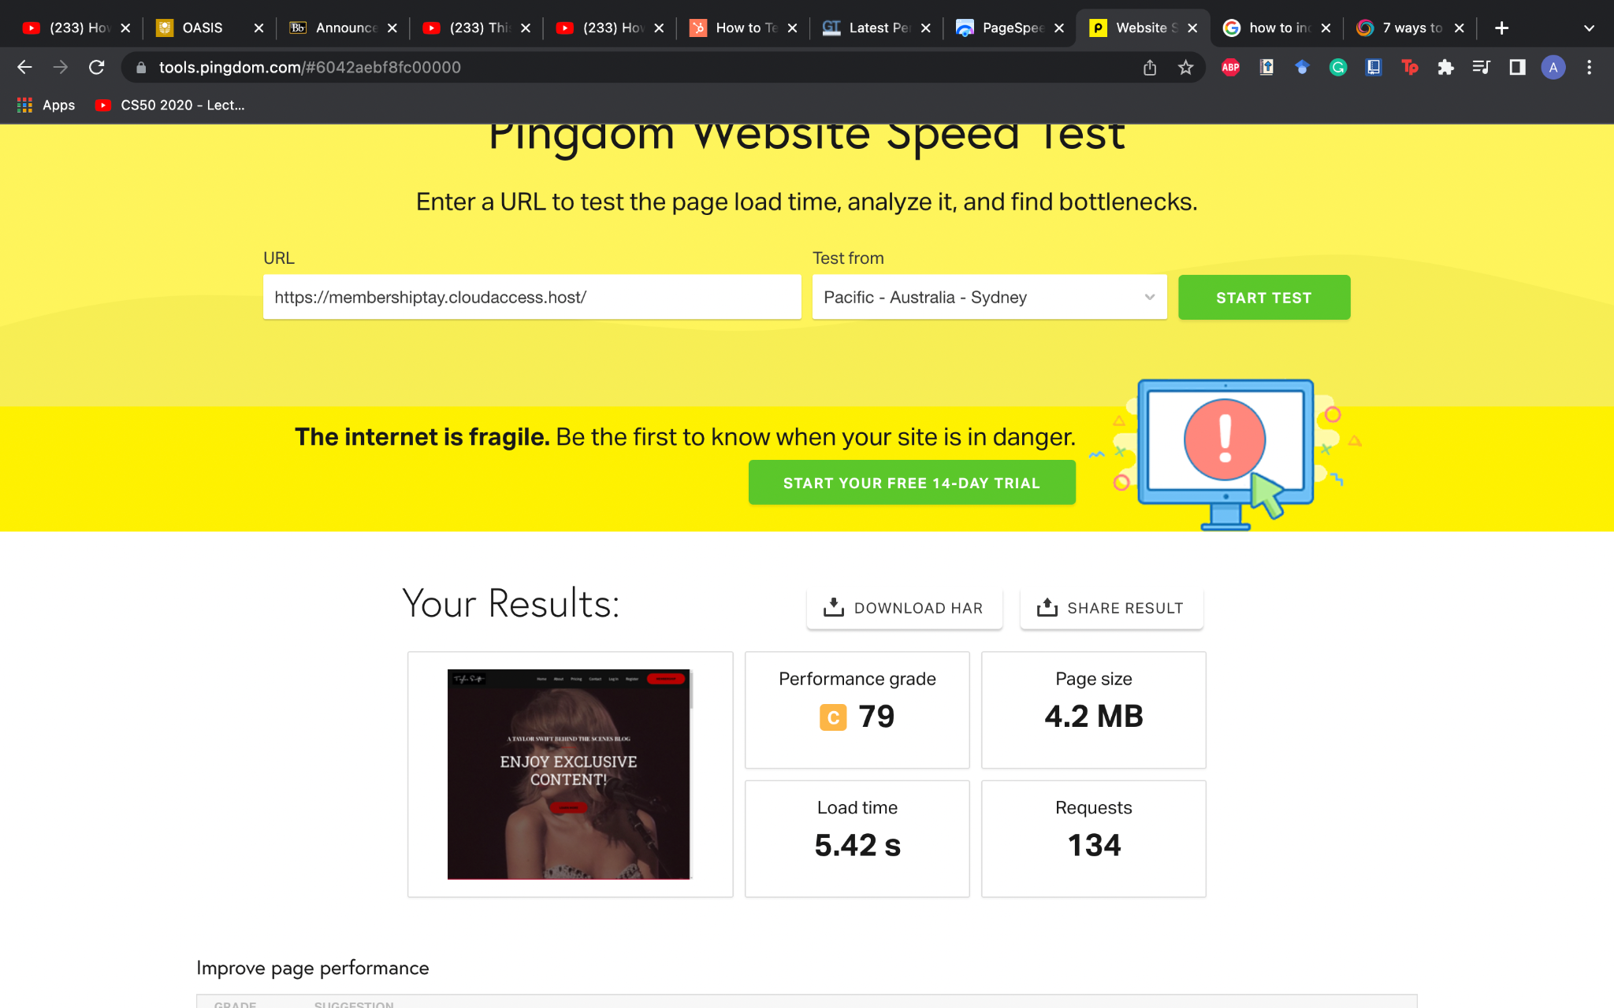

API testing:

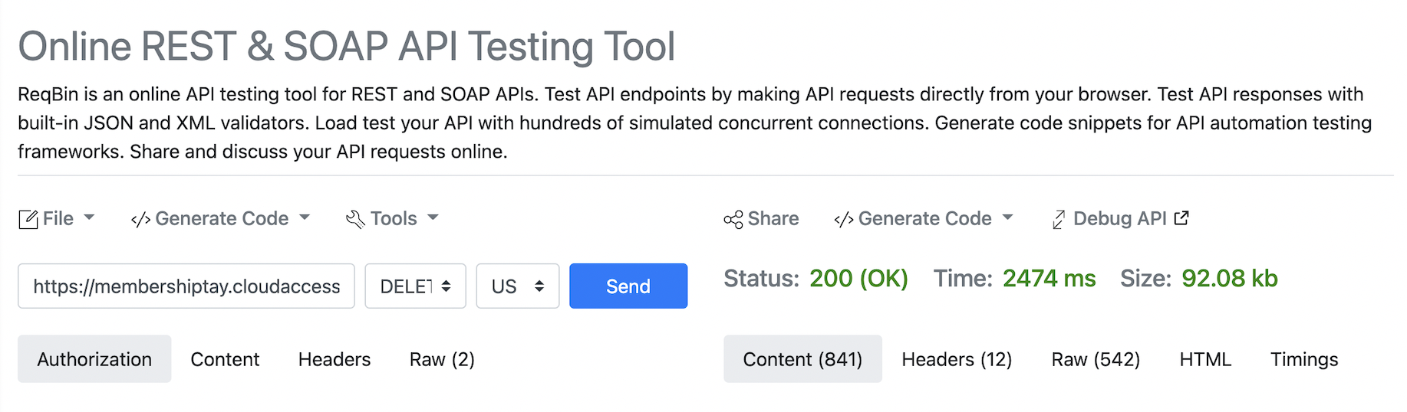

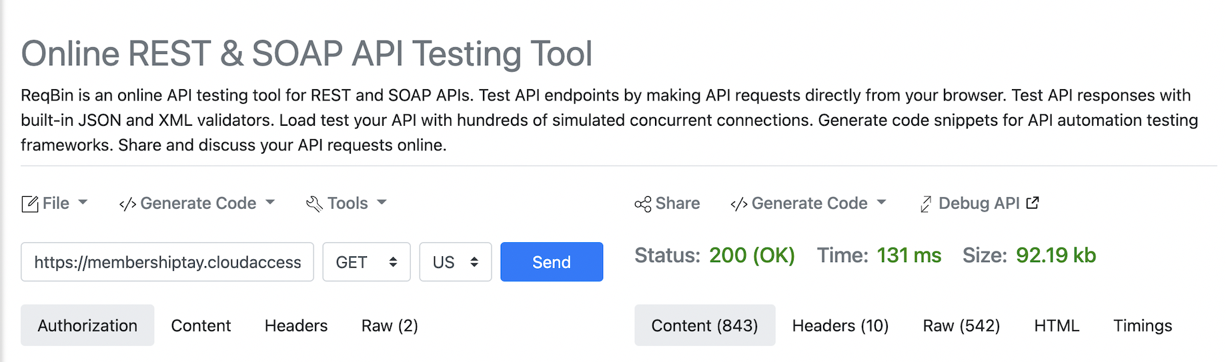

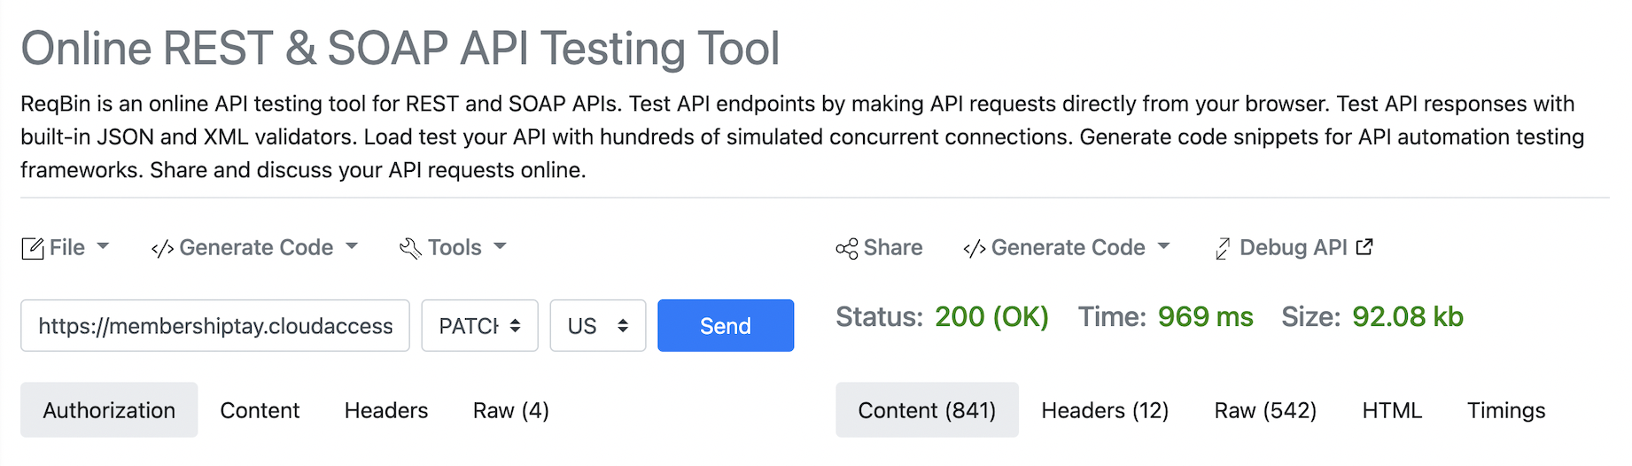

# Non-conformance report

User Guide:



This the first thing you see when you go on to the website.

Then you can scroll and see what the home page has to offer. After that, if you are interested in any other services.

For example:

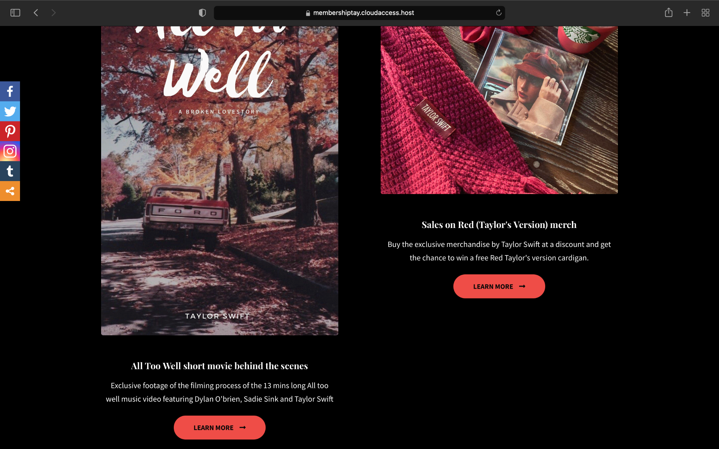

If you want to learn about this service offering : All Too Well short movie behind the scenes and click on learn more.

It will redirect to the membership sign up page:

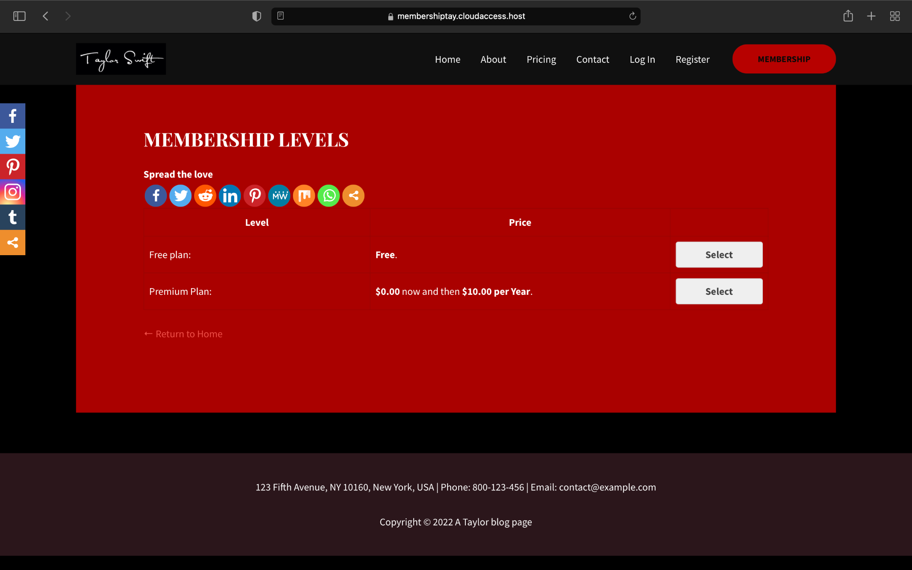

Whereby you can register to any membership plan, for this user guide sake, we are going to use the free plan:

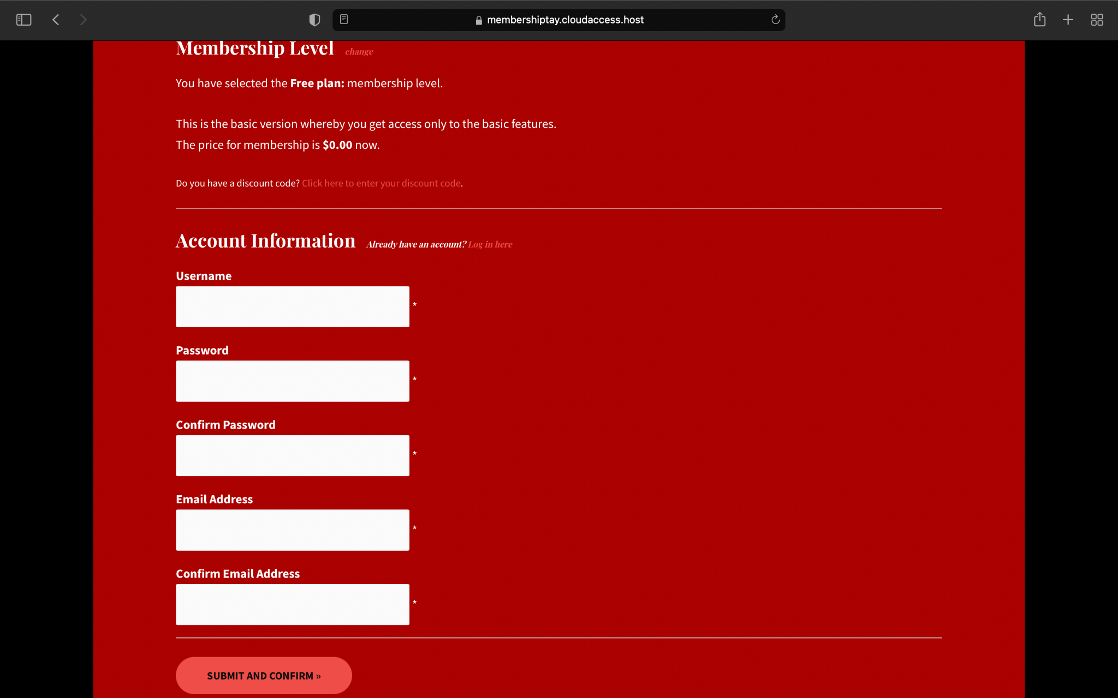

After signing up, you will get a confirmation message and email.

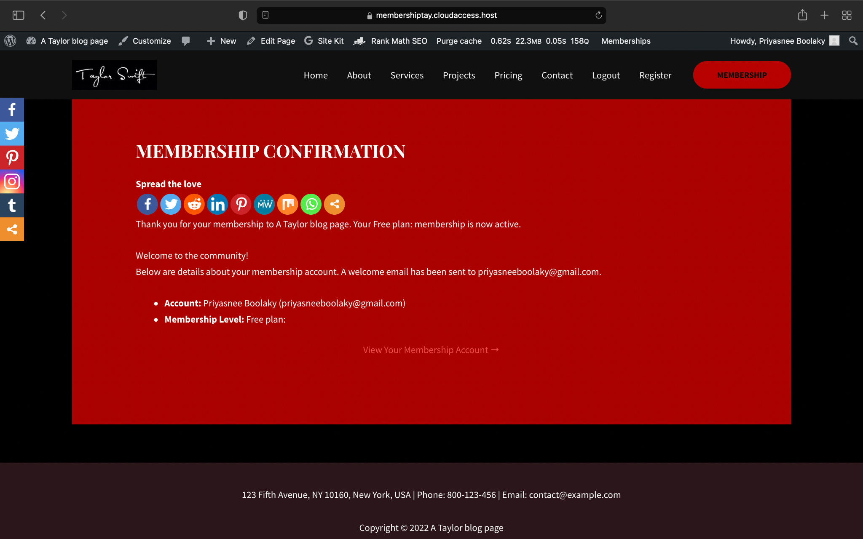

Now that you are a member, you can get access to a new navigation menu:



Now, you get access to the servies and projects tab:

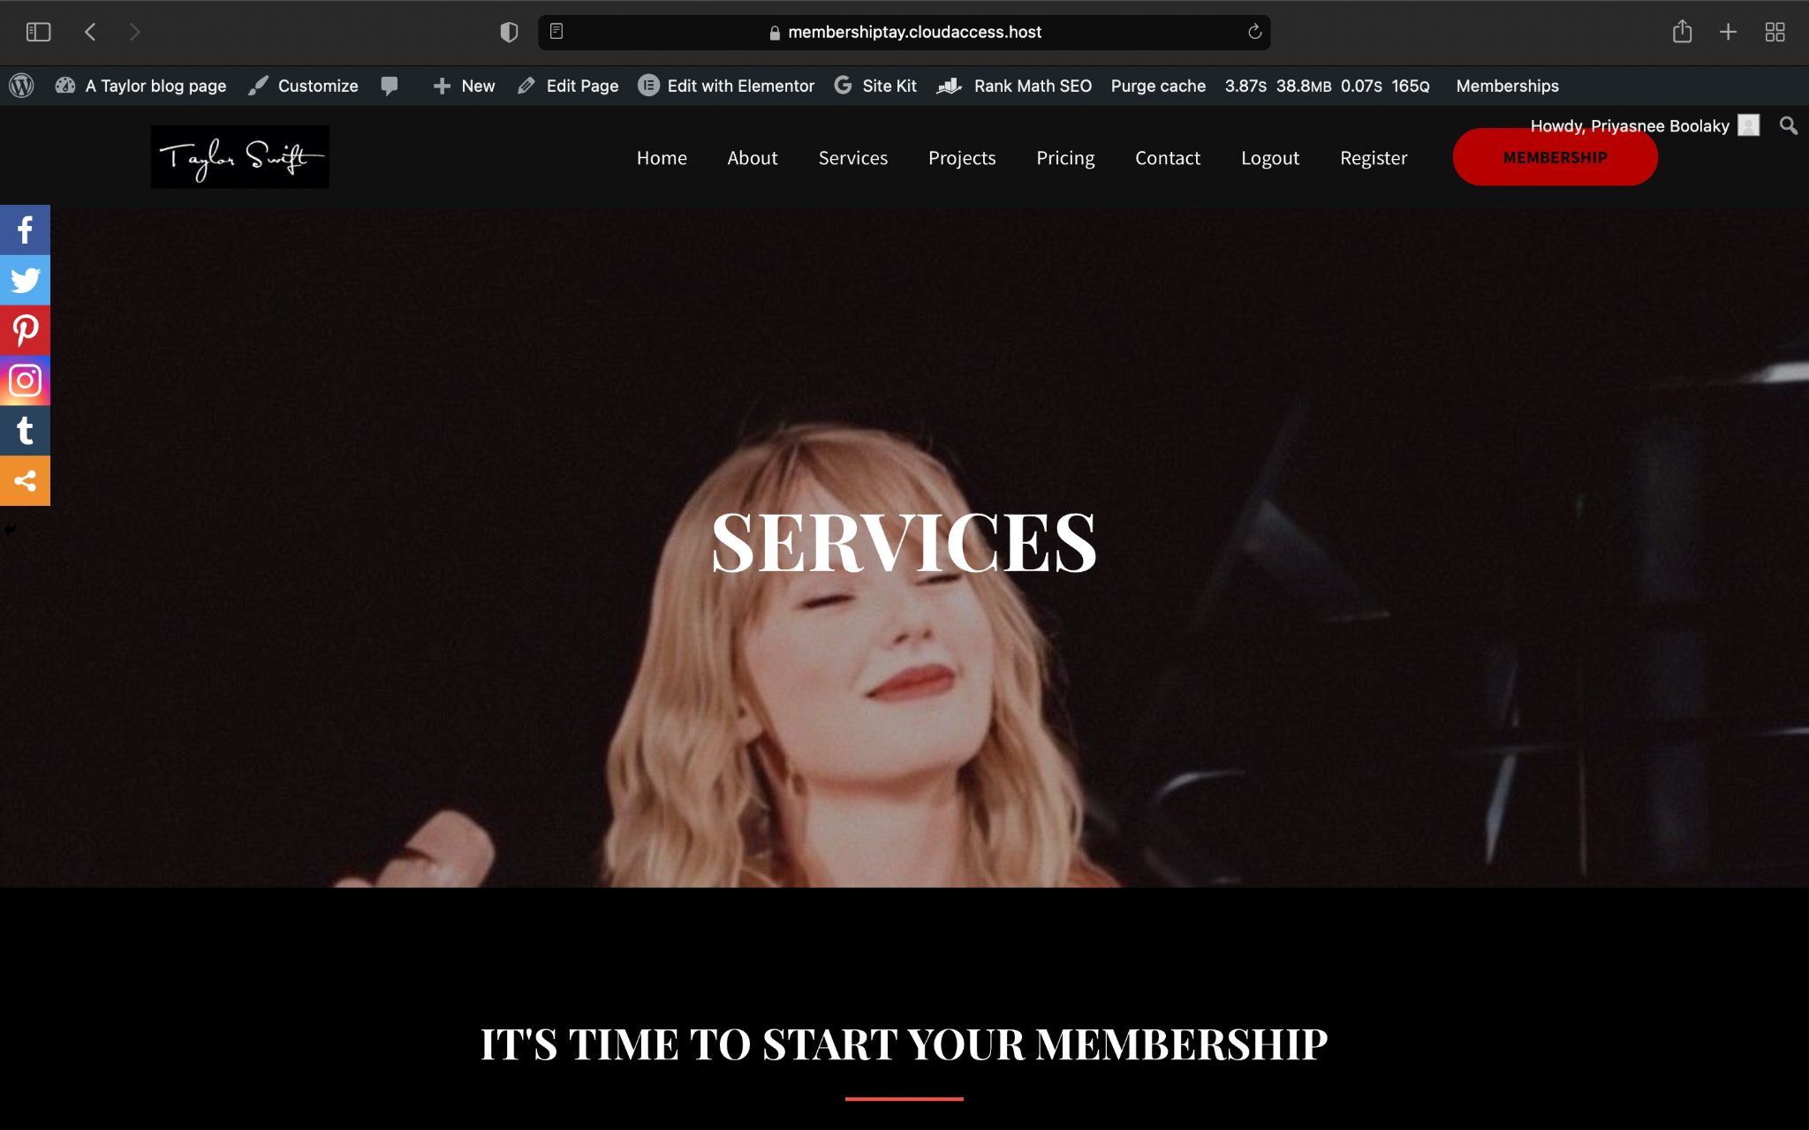

Any member can get full access to the website.

Complex Feature: Membership and registration module.

These features are really complex and i had to deal with this cause all the best membership plug-ins and features comes at a premium.The Premium level membership requires already registered users to create a new account as to include the payment module.

How do i plan to solve this in the future?

I plan to invest in a premium plug-in called Ultimate Membership Pro, it is an easy to use and incredibly good plug-in features such as creating the prices widgets for you and most of the process are automated to create crisp looking pages and services.

Difficulty Rate:

I would 30%, the only difficult part of the website is the sign-up and registering as a member.

Future Work:

There is a lot of work that is missing from this website as such in the future:

* I would like to add more functionality to my website such as a community page where people can discuss and interact.
* I would also like to integrate a selling platform module where people can sell and buy specific items.
* I would like to add a booking module directly on the page where people can book the event on the site itself instead of having to go to a third party website.

Link to the website:

<https://membershiptay.cloudaccess.host>

Adminstrator details:

Username: hjbvbfsd-ca

Password: 123456Blah12

Premium user: Subscriber

Username: Shu

Password: Bro1234567

Free user: Subscriber

Username : 123455

Password: Blahblah1213

# References:

Newcomer, Colin. 2016. “The 8 Best WordPress Page Builder Plugins Compared 2022.” AThemes. aThemes. September 25, 2016. <https://athemes.com/reviews/best-wordpress-page-builder-plugins-compared/>.

Spacey, John. 2018. “What Is System Architecture?” Simplicable. 2018. <https://simplicable.com/new/system-architecture-definition>.

“WordPress Plugins.” 2022. WordPress.org. 2022. <https://wordpress.org/plugins/>.

“WP-Optimize vs W3 Total Cache Comparison [05-2022].” 2022. Webstick.blog. 2022. <https://webstick.blog/wp-optimize-vs-w3-total-cache#:~:text=Wp%2DOptimze%20offers%20a%20little,is%20clearly%20the%20best%20choice>..